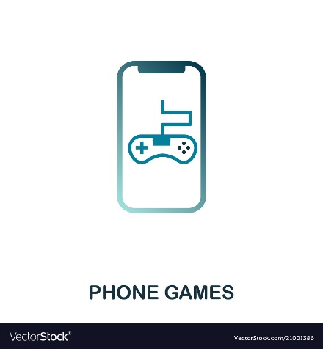

**Mobile Games Market**

* **Question/Problem statement:**

"The Mobile Games Market'' is worth billions of dollars, with companies spending vast amounts of money on the development and marketing of these games to an equally large market. Using this data set, insights can be gained into a sub-market of this market, strategy games.

* **Data Description:**

I extracted my data set from Data World.

* + Columns: ()
  + Data type: (char, float, date)
  + Rows
  + Data size (The data set has 17002 rows × 17 columns)
* **Tools:**
  + Programs: Python using Jupiter, DB Browser, SQLite
  + Libraries: Pandas, NumPy, Matplotlib and Seaborn
  + Plots: Bar Chart, figure plots
* **MVP Goal**: You could use the number of ratings as a proxy indicator for the overall success of a game, and then work out what factors make a successful game. Or you could measure the state of the market over time and try predicting where it is headed.

And I think an analysis for the apps of games would be accurate and easier understanding.